

East West University

Department of Computer Science and Engineering

Semester : Spring 2021
Course Title : Electrical Circuits
Course Code : CSE 209
Section : 03

Experiment Number : 05
Experiment Title : Verification of Superposition Theorem

Student Name: Md. Rakibur Rahman
ID: 2019-3-60-113

Date of Performance: 07.04.2021
Date of Submission: 13.04.2021

Objectives:
- To verify the superposition theorem theoretically, experimentally, and using PSpice simulation.

Circuit Diagram:
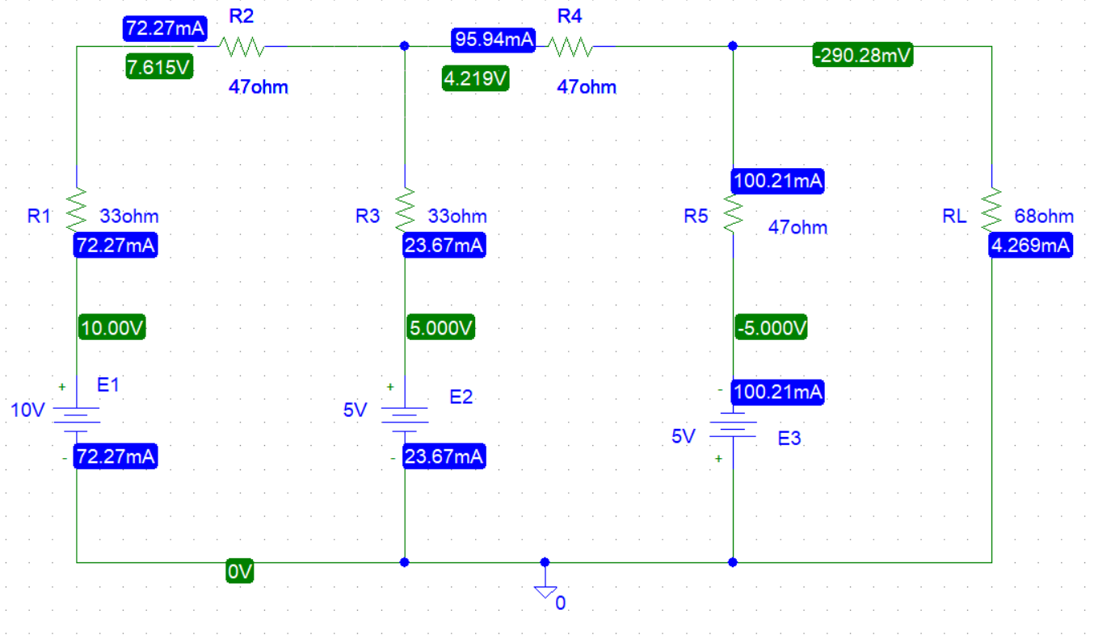 Figure 1. Circuit with all sources active.
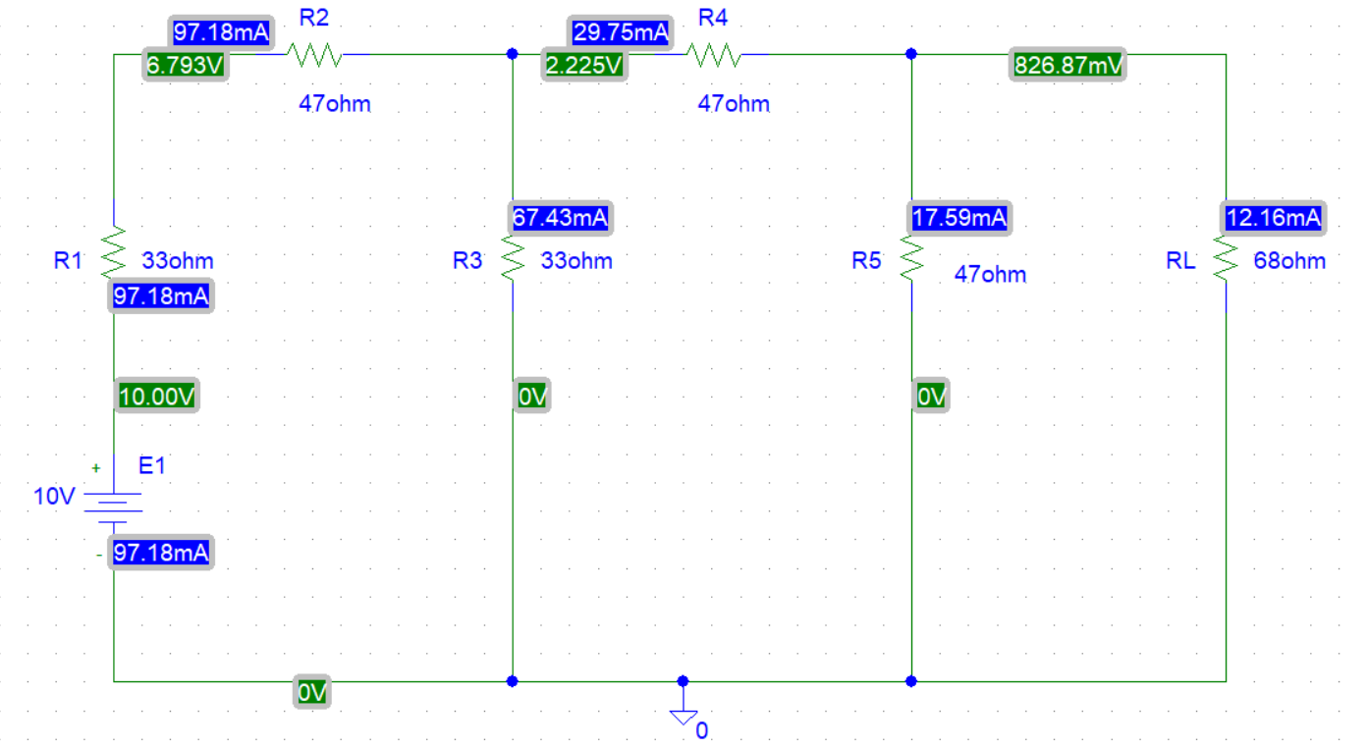 Figure 2. Circuit with E₁ source active.
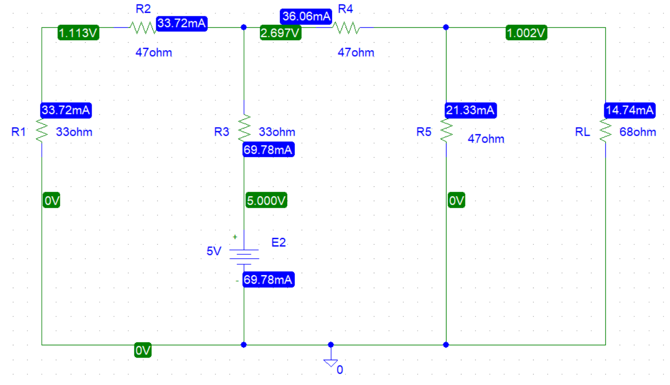
Figure 3. Circuit with E₂ source active.
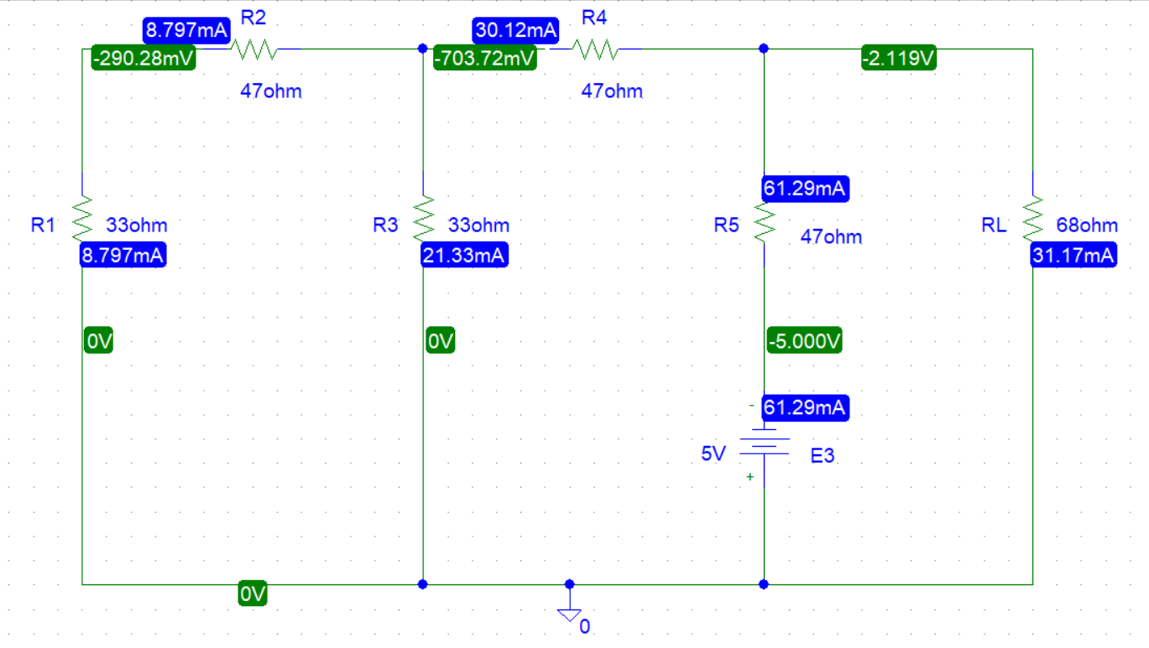

Figure 4. Circuit with E₃ source active.

Experimental Datasheet:

Value of E₁(V) | Value of E₂ (V) | Value of E₃ (V) | Value of I_{L} with all sources active(mA) | Value of I_{L1} with only E₁ active(mA) | Value of I_{L2} with only E₂ active(mA) | Value of I_{L3} with only E₂ active (mA) | Value of Resistors(Ω)
10 | 5 | -5 | -4.269 | 12.16 | 14.74 | -31.17 | R₁=33Ω  R₂=47Ω  R₃=33Ω  R₄ = 47Ω  R₅ =47Ω  R_{L} = 68Ω

Value of E₁(V) | Value of E₂ (V) | Value of E₃ (V) | Value of I_{L} with all sources active(mA) | Value of I_{L1} with only E₁ active(mA) | Value of I_{L2} with only E₂ active(mA) | Value of I_{L3} with only E₂ active (mA) | Value of Resistors(Ω)
10 | 5 | -5 | -4.269 | 12.16 | 14.74 | -31.17 | R₁=33Ω  R₂=47Ω  R₃=33Ω  R₄ = 47Ω  R₅ =47Ω  R_{L} = 68Ω

Answers to the post lab report questions:
1. For figure 1:
Applying KVL at mesh 1,
33 i₁+47i₁ + 33(i₁- i₂) =10-5
33 i₁+47i₁ +33i₁-33i₂=5
113i₁-33i₂+0i₃=5…….(1)
Applying KVL at mesh 2,
33(i₂- i₁)+ 47i₂+47(i₂- i₃)=5+5
33i₂-33 i₁+ 47i₂+47i₂-47 i₃=10
-33 i₁+ 127i₂-47 i₃=10…….(2)
Applying KVL at mesh 3,
47(i₃- i₂)+68i₃=-5
47i₃-47 i₂+68i₃= -5
0i₁-47 i₂+115i₃= -5…….(3)
Solving equation 1,2 & 3,
i₁=0.07227A=72.27mA
i₂=0.09594A=95.94mA
i₃= -4.269×10⁻³A= -4.269mA
here, i₃=I_{L}= -4.269mA

For figure 2:
Applying KVL at mesh 1,
33 i₁+47i₁ + 33(i₁- i₂) =10
33 i₁+47i₁ +33i₁-33i₂=10
113i₁-33i₂+0i₃=10…….(1)
Applying KVL at mesh 2,
33(i₂- i₁)+ 47i₂+47(i₂- i₃)=0
33i₂-33 i₁+ 47i₂+47i₂-47 i₃=0
-33 i₁+ 127i₂-47 i₃=0…….(2)
Applying KVL at mesh 3,
47(i₃- i₂)+68i₃=0
47i₃-47 i₂+68i₃= 0
0i₁-47 i₂+115i₃= 0…….(3)
Solving equation 1,2 & 3,
i₁=0.09718A=97.18mA
i₂=0.02975A=29.75mA
i₃= 0.01216A= 12.16mA
here, i₃=I_{L1}= 12.16mA

For figure 3:
Applying KVL at mesh 1,
33 i₁+47i₁ + 33(i₁- i₂) = -5
33 i₁+47i₁ +33i₁-33i₂= -5
113i₁-33i₂+0i₃= -5…….(1)
Applying KVL at mesh 2,
33(i₂- i₁)+ 47i₂+47(i₂- i₃)=5
33i₂-33 i₁+ 47i₂+47i₂-47 i₃=5
-33 i₁+ 127i₂-47 i₃=5…….(2)
Applying KVL at mesh 3,
47(i₃- i₂)+68i₃=0
47i₃-47 i₂+68i₃= 0
0i₁-47 i₂+115i₃= 0…….(3)
Solving equation 1,2 & 3,
i₁= -0.03372A= -33.72mA
i₂=0.03606A=36.06mA
i₃= 0.01474A= 14.74mA
here, i₃=I_{L2}= 14.74mA

For figure 4:
Applying KVL at mesh 1,
33 i₁+47i₁ + 33(i₁- i₂) = 0
33 i₁+47i₁ +33i₁-33i₂= 0
113i₁-33i₂+0i₃= 0…….(1)

Applying KVL at mesh 2,
33(i₂- i₁) + 47i₂+47(i₂- i₃)=5
33i₂-33 i₁+ 47i₂+47i₂-47 i₃=5
-33 i₁+ 127i₂-47 i₃=5…….(2)
Applying KVL at mesh 3,
47(i₃- i₂) +68i₃= -5
47i₃-47 i₂+68i₃= -5
0i₁-47 i₂+115i₃= -5…….(3)
Solving equation 1,2 & 3,
i₁=8.797×10⁻³A = 8.797mA
i₂=0.03012A=30.12mA
i₃= -0.03117A= -31.17mA
here, i₃=I_{L3}= -31.17mA

Solving the equations we get,
I_{L} = -4.269mA = -4.27mA
I_{L1}=12.16mA
I_{L2}= 14.74mA
I_{L3}=-31.17mA
I_{L} = I_{L1}+ I_{L2}+I_{L3}
=12.16+14.74-31.17
= -4.27mA
It holds the superposition theorem.
As the experiment was done in PSpice, the values of current are same. Thus , there is no discrepancy.

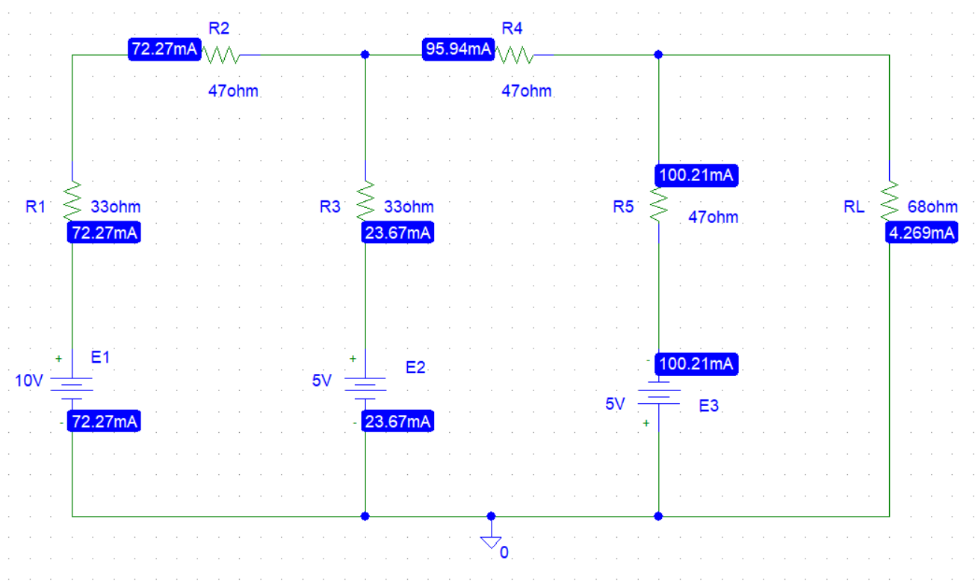 Figure 1. Circuit with all sources active.
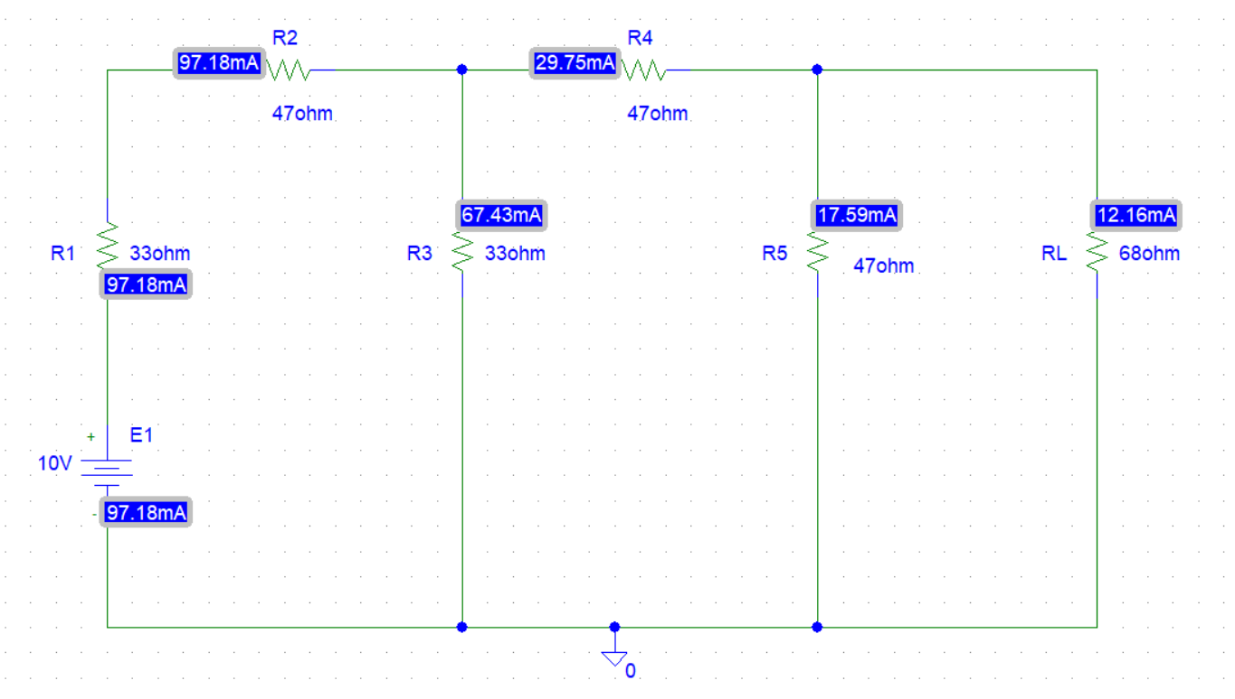 Figure 2. Circuit with E₁ source active.
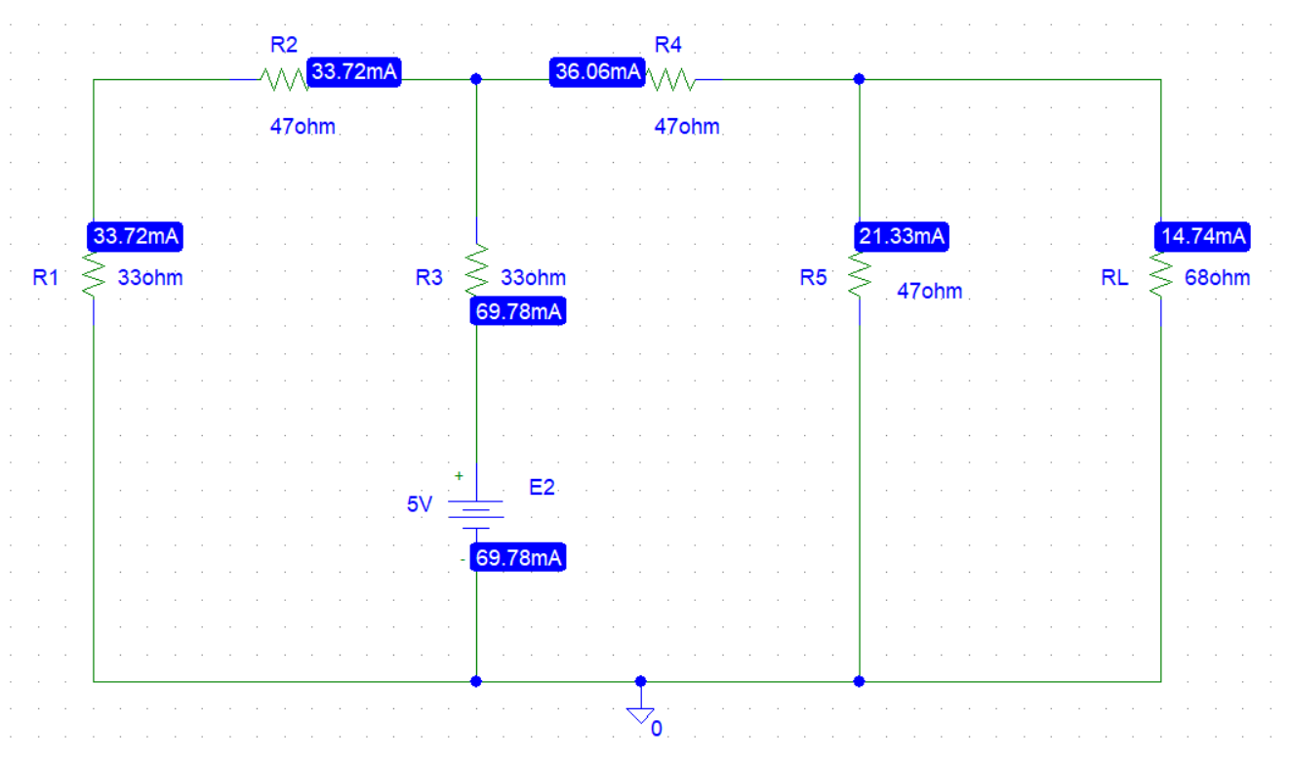
Figure 3. Circuit with E₂ source active.
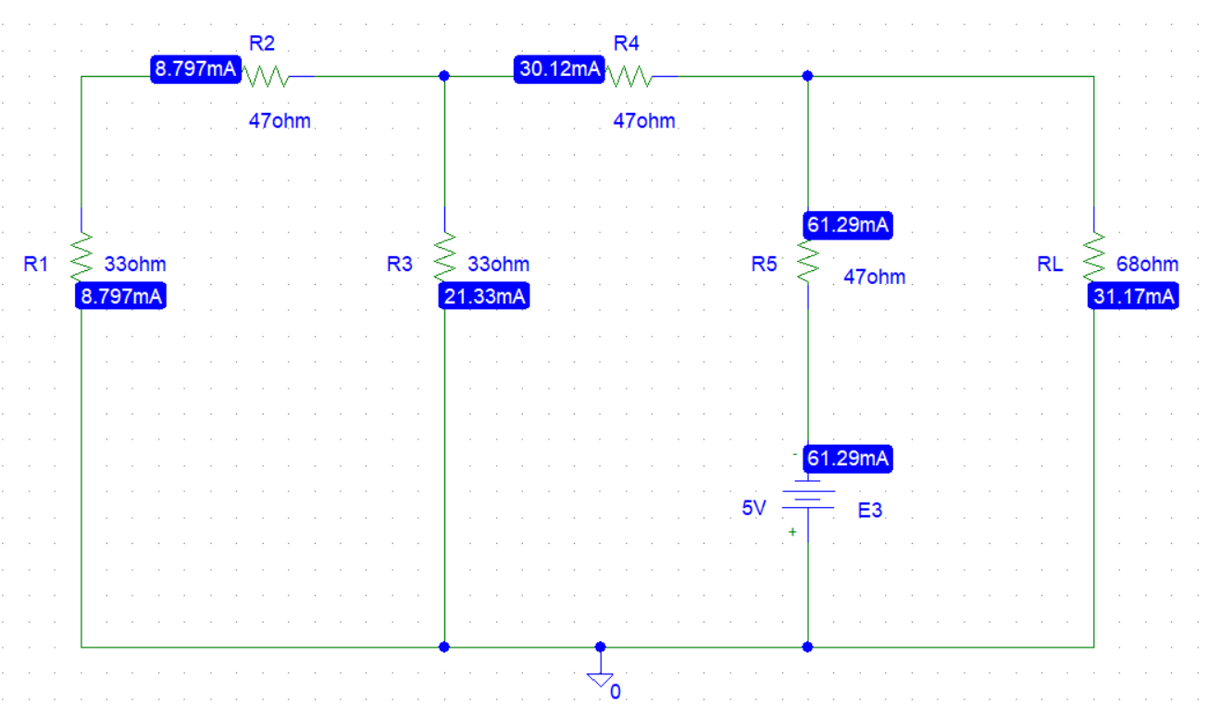
Figure 4. Circuit with E₃ source active.
Here ,
I_{L} = -4.269mA = -4.27mA
I_{L1}=12.16mA
I_{L2}= 14.74mA
I_{L3}=-31.17mA
I_{L} = I_{L1}+ I_{L2}+I_{L3}
=12.16+14.74-31.17
= -4.27mA
It holds the superposition theorem.
As the experiment was done in PSpice, the theoretical values & the PSpice values of current are same. Thus , there is no discrepancy.

Conclusion:
From the experiment we learnt about the superposition theorem. At first we calculated I_{L} .Then we made independent sources inactive (only one at a time) and calculated I_{L1} , I_{L2} , I_{L3} .We found that the algebraic sum of I_{L1} , I_{L2} , I_{L3} is equal to I_{L.}Thus, Superposition theorem was verified. This experiment was done in PSpice so,the theoretical values & the PSpice values of current are same.

